**Pizza sales SQL Queries**

To Retrieve all the data in your table:

select * from pizza_sales

KPI’s:

1.Total_Revenue:

select sum(total_price) as Total_Revenue from pizza_sales

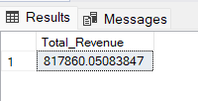

2.Average order value:

select sum(total_price)/count(distinct order_id) as Avg_order_value

from pizza_sales

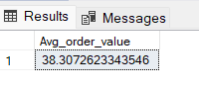

3.Total pizza sold:

select sum(quantity) as Total_pizza_sold from pizza_sales

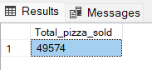

4.Total orders:

select count(distinct order_id) as Total_orders from pizza_sales

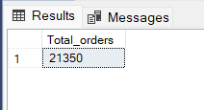

5.Average pizzas per order:

SELECT CAST(CAST(SUM(quantity) AS DECIMAL(10,2)) /

CAST(COUNT(DISTINCT order_id) AS DECIMAL(10,2)) AS DECIMAL(10,2))

AS Avg_Pizzas_per_order

FROM pizza_sales

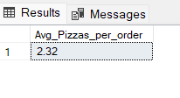

6.Daily trend for Total orders:

select DATENAME(dw,order_date) as order_date,count(distinct order_id) as Total_orders from pizza_sales

group by DATENAME(dw,order_date)

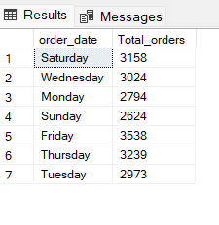

7.Daily trend for Total hours:

select DATEPART(HOUR,order_time) as order_hour,count(distinct order_id) as Total_orders from pizza_sales

group by DATEPART(HOUR,order_time) order by order_hour

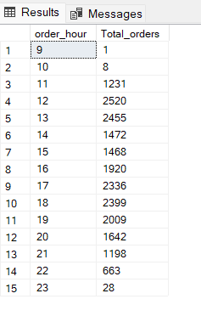

8.% of sales by Pizza category:

SELECT pizza_category, CAST(SUM(total_price) AS DECIMAL(10,2)) as total_revenue,

CAST(SUM(total_price) * 100 / (SELECT SUM(total_price) from pizza_sales) AS DECIMAL(10,2)) AS PCT

FROM pizza_sales

GROUP BY pizza_category

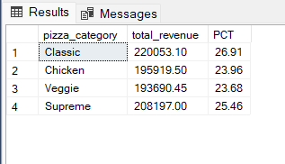

9.% of sales by Pizza size:

SELECT pizza_size, CAST(SUM(total_price) AS DECIMAL(10,2)) as total_revenue,

CAST(SUM(total_price) * 100 / (SELECT SUM(total_price) from pizza_sales) AS DECIMAL(10,2)) AS PCT

FROM pizza_sales

GROUP BY pizza_size

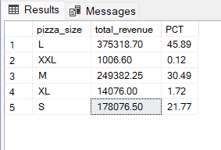

10.Total pizzas sold by Pizza category:

SELECT pizza_category, SUM(quantity) as Total_Quantity_Sold

FROM pizza_sales

GROUP BY pizza_category

ORDER BY Total_Quantity_Sold DESC

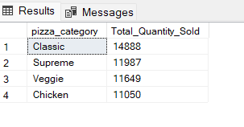

11.Top 5 best sellers by total pizzas sold:

SELECT Top 5 pizza_name, SUM(quantity) AS Total_Pizza_Sold

FROM pizza_sales

GROUP BY pizza_name

ORDER BY Total_Pizza_Sold DESC

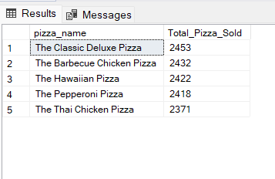

12. Bottom 5 best sellers by total pizzas sold:

SELECT Top 5 pizza_name, SUM(quantity) AS Total_Pizza_Sold

FROM pizza_sales

GROUP BY pizza_name

ORDER BY Total_Pizza_Sold DESC

